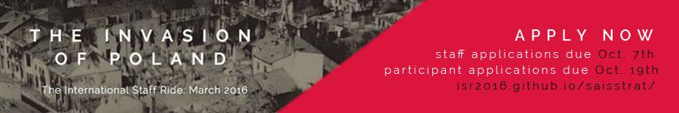
Johns Hopkins SAIS | Strategic Studies
International Staff Ride 2016

ISR 2016: State Under Siege
Participant Application

Applications are due in hardcopy to the Strategic Studies Office (Rome 708) no later than 5:00PM, Monday, 19 October 2013. Please contact the ISR Team at isrqm2016@gmail.com with any questions. Selected participants will be notified in early November.

Name:

JHED ID:

Prefered Email:

Year Status (Circle One)

MA1 MA2 MA3 MA4 MIPP1 MIPP2 PHD

Concentration:

Local Address:

List any participation in Strategic Studies courses and department activities, as well as other SAIS involvement:

Briefly describe any experience, knowledge, skills, or abilities that you could contribute to the staff ride:

The next two questions are informative for us but will not affect your application.

All participants will depart Washington, DC on Friday, March 11th 2016. The staff ride will conclude on Friday, March 18th. Participants may choose to depart Poland on either Friday, March 18th or Sunday, March 20th. If you choose the later departure, you will be responsible for securing your own accommodations for your subsequent time in Poland. If selected to participate, do you intend to depart on Friday, March 18th or at a later date?

Indicate 2 presentation topic areas in which you have special interest or expertise:
[ ] Tactics and combat experiences  [ ] Civilian experiences of war  [ ] Civilian/political leadership  [ ] European Diplomacy | [ ] Ideology and Racialized Politics  [ ] Media and Propaganda  [ ] Intelligence and deception  [ ] Military leadership and strategy

Please respond to three of the six prompts below. You MUST answer the question from the first group. Choose two additional questions from the second group. Limit each response to 700 words and attach them to this form. Your choices will help the staff and professors gauge your interest and understand which issues you find most compelling.

Suggested readings for each question are available on Blackboard divided by question. To access the International Staff Ride Blackboard site, log in to Blackboard using your JHED ID. Under the “Community” tab, search for “Poland” in the Search Catalog tool at the top of the screen, and then select “International Staff Ride 2016: Poland.” Add yourself to the site by clicking on the arrows to the right of the site name link and choosing “Enroll.” To access the recommended readings, open the folder marked “Application Materials.”

This question is required.

- Poland’s rapid collapse is often attributed to multiple factors including strategic breakdowns in Poland’s diplomatic, political, or military command and control systems; unfavorable geography; lack of Allied support; German doctrinal, technological, or manpower superiority; and the unanticipated Soviet invasion. What was the most important factor in Poland’s defeat? Was this defeat inevitable given the campaign’s preconditions?

Please answer two of the following five questions.

- It’s early March 1939, and you’re a member of the Polish General Staff. You must choose whether to advocate for implementation of the newly proposed defensive plan, called “Plan West.” What are its political, diplomatic, and military advantages and disadvantages?

- You are Polish Marshal Rydz-Śmigły on September 6. Your subordinate, General Kutrzeba, who is commanding elements of Army Poznan and Army Pomorze near the Bzura River, asks for permission to launch a counterattack against the German 8th and 4th Armies. You can let him launch his attack, or order him to support the defense of Warsaw. What should you do?

- It is August 24, 1939, and you are Adolf Hitler. You must choose whether to begin the invasion of Poland or delay it. What are the dangers of launching the offensive? What are the dangers of waiting? What should you do?

- It is August 31, and you are an ethnic German living in the “free city” of Danzig. Polish and German leaders have rattled sabers since March, and war is in the air. What is your opinion on the coming war between Germany and Poland? How have ethnic and political tensions in Danzig relating to the leadup to war affected you? Do you consider yourself a Nazi?

- As Martial Stalin, you decided to approve of the secret “Molotov-Ribbentrop Pact” on August 23. It is now the second week of September, and Germany is pressing you to intervene in Eastern Poland. What major factors compelled you to seek an accord with Nazi Germany? Why are you reluctant to order the Red Army to invade Poland?

