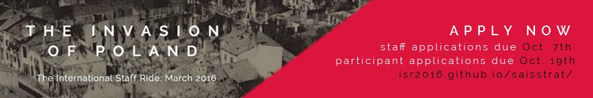

Johns Hopkins SAIS | Strategic Studies
International Staff Ride 2016

ISR 2016: State Under Siege
Staff Application Instructions

Thank you for your interest in joining the 2016 International Staff Ride Staff. We have open spots for four research assistants, a logistics assistant, a public affairs assistant, and a gunny. Descriptions for all of these roles can be found below.

All staff applications will consist of a resume, and a brief cover letter explaining your interest in the position, and the participant application without the optional essays.

Please send all application materials to isrqm2016@gmail.com with the desired position title in the subject line by 11:59 pm on October 7, 2015. Interviews for staff positions will occur on Saturday, October 10 and Sunday, October 11 between 11 am - 4 pm. If you will not be available on those dates please let us know.

If you are not accepted for a staff position, you are still encouraged to submit a participant application by Monday, October 19.

The ISR 2016 open staff positions:

Research Assistant:

Role:
- Support the Research Leads in shaping the story of the staff ride through substantial historical research.
- Assist in identifying key themes and sources relevant to the campaign and formulating character roles and questions.
- Assist participants in preparing character presentations.

Prior knowledge of the 1939 September Campaign is not necessary; applicants will be evaluated based on research ability and the essay submitted as part of the application. We strongly advise that you review the recommended readings, which are available on Blackboard, prior to writing your essay. No additional outside research is required, although it will not be penalized.

Four positions available, two reserved for first year MA students, two open to all students.

Logistics Assistant:

Role:
- Support the logistics lead in securing reservations with German and Polish transportation, lodging, and food vendors.
- Arrange for all meals, including coordinating menu choices, cost estimates and negotiations, contracts, and documentation.

We are looking for someone who is good at budgeting their time. Applicants with a background in event planning are prefered. Knowledge of Polish is considered a plus.

One position, with preference for first year MA students.

Public Affairs Assistant:

Role:

- The PAA will assist the PAO with ISR booklet layout design and assembly, ISR t-shirt design and coordination, ISR posters, ISR pre-departure promotional events, and general ISR front-facing media and materials.

We are looking for someone who works well on a team and can deliver on a deadline. Experience with Adobe Photoshop/Adobe Illustrator, Basic HTML/CSS, and Photography will all be considered.

One position, with preference for first year MA students.

Gunny:

Role:
- Assist the Quartermasters with the organization and management of participants both prior to and during the staff ride.
- During the staff ride, responsible for execution of the timeline and personnel accountability.

We are looking for someone who is flexible and has experience with coordinating large groups of people.

One position, open to all students.

